19 EHS – 132
B.Tech Degree Examination
- Semester
Communicative English II
Effective from the Admitted Batch 2019-20

Model Paper
Time: 3 Hrs Max Marks: 60

Instructions: Answer all questions.
Section ‘A’ carries 20 Marks & Section ‘B’ carries 40 Marks.
Section ‘A’ consists of 10 short questions. Each carries 2 Marks.

Section ‘B’ consists of 5 questions, each carrying 8 marks with internal choice.
All parts of the Section must be answered at one place only.
Figures in the right hand margin indicate marks allotted.

Section A | 10X2=20M

Answer all Questions:

  - Write about a/any Nobel laureate that has inspired you.

  - Do you believe that difficulties in one’s life alone would help one to rise in life?

  - Do you need to uproot trees for setting up our shelter ?

  - Why are we not able to treat everyone alike unmindful of one’s rank and file ?

  - Is the impact of the films positive or negative?

  - Fill in the blanks with appropriate conjunctions/sentence connectors.

        - _____________you give up your bad habits, you cannot improve.

        - Around 200 plant species have been domesticated for food. ________ , at present more than 70% of the food supply of the human population is obtained from just 12 kinds of plants.

- Recognize redundant words and phrases in the following sentences and re-write them correctly.

        - The prices of car companies have fallen down by 30% in the last one week.

        - The reason why I did not attend the party last night was because I had a headache.

    - Fill in the blanks with appropriate pronouns.

        - Leaders of these two countries have already gone public on ________ plans to back Bangladesh.

        - The parents were overjoyed to see _______ children return home safely.

      - Complete the sentence with an appropriate word given in the brackets.

        - I have the ___________to visit Dubai next year. (possibility/ opportunity)

        - It was not a ___________ thing to do. (sensible/sensitive)

- Edit the paragraph given below.

The Moon is a barren, rocky world without air and water. It has dark lava plain on its surface. The Moon is filled with craters. It has no light of its own. It gets its light from the Sun. The Moon keep changing its shape as it moves round the Earth.
Section B

Answer all Questions: | 5X8= 40M

- a) As a member of your residential society, write an email addressing the Inspector of local

police station, complaining about the miscreants creating nuisance with their rash bike

riding every evening in your locality. |  |  |  | 6M
b) Fill in the blanks with appropriate collocations choosing the words from Column
A and Column B.
 |  |  |  | 2x1= 2M
 | column A | column B
 | popular | idea
 | preconceived | interaction
 | Informal | view
 | strange | belief

- An opinion formed beforehand without adequate evidence is a __________.

- This mode of delivery has enabled a more ________between lecturers and students.

OR

2. a. You are an intern in ABC Consulting Pvt. Ltd. Write an email to your Manager updating him

about your work progress and challenges you are facing. 6M

b. Fill in the blanks with appropriate collocations choosing the words from Column
A and Column B.
 |  |  |  | 2x1= 2M
 | column A | column B
 | unnatural | aliens
 | limited | information
 | exotic | news
 | detailed | species

  - Fifty is the number of ________ that have rushed in to fill the new ecological niches. ii. I did not have further problems as she sent me _________about the project.

- a.Assuming you are Tejpal Singh, draft a letter addressing the editor of The Hindu news paper, pointing the widespread use of single use polythene bags in spite of a ban on them in the city.

6M

b. Change the voice in the following sentences. | 2X1=2M

i. Akhil generously donated money to the homeless shelter.

ii. Whom did you laugh at?

OR

- a. Assume you are Ram Prasad a customer of Union Bank of India, Rushikonda branch.

You have noticed that the bank statements of the last two years show that the annual maintenance charges were deducted twice a year. Draft a complaint letter to be sent to the
Regional Manager, Chennai. | 6M
b. Change the voice in the following sentences. | 2x1= 2M
i. Children fly kites during spring season.

  - Why did he punish you?

- Tech-Mahindra is looking for a dynamic Web Developer. Requirements: B.Tech degree with minimum of 2 years experience, script, result oriented, excellent numerical skills
and communication skills. Apply with your resume and cover letter. | 8M

OR
- Compaq Computers Ltd. has an urgent need for a Junior Software Engineer. Apply with your resume
and cover letter. | 8M
7. a. Make a précis of the given passage and give a suitable title. | 6M

Teaching is the noblest of professions. A teacher has a sacred duty to perform. It is he on whom rests the responsibility of moulding the character of young children. Apart from developing their intellect, he can inculcate in them qualities of good citizenship, remaining neat and clean, talking decently and sitting properly. These virtues are not easy to be imbibed. Only he who himself leads a life of simplicity, purity and rigid discipline can successfully cultivate these habits in his pupils.

Besides a teacher always remains young. He may grow old in age, but not in spirit. Perpetual contact with budding youth keeps him happy and cheerful. There are moments when domestic worries weigh heavily on his mind, but the delightful company of innocent children makes him overcome his transient moods of despair.

b. Fill in the blanks with appropriate idioms. | 2X1=2M

- The flu I had a few weeks ago which prevented me from going on holiday with my friends was _______. They had terrible time. Everything went wrong and it cost them a lot of money.
 |  | a. | best of both worlds | b. a blessing in disguise |  |  | c. over the moon
ii. |  | The interview for the new job was ________. They asked me really easy questions.
 |  | a. | chip on the shoulder | b. an arm and a leg |  |  | c. a piece of cake
 |  |  |  |  | OR
8. a. | Make a précis of the given passage and give a suitable title. |  |  |  |  |  | 6M

English education and English language have done immense good to India, in spite of their glaring drawbacks. The notions of democracy and self-government are the boon of English education. Those who fought and died for mother India's freedom were nursed in the cradle of English thought and culture. The West has made contribution to the East. The history of Europe has fired the hearts of our leaders. Our struggle for freedom has been inspired by the struggles for freedom in England, America and France. If our leaders were ignorant of English and if they had not studied this language, how could they have been inspired by these heroic struggles for freedom in other lands? English, therefore, did us great good in the past and if properly studied will do immense good in future.

English is spoken throughout the world. For international contact, our commerce and trade, for the development of our practical ideas, for the scientific studies, English is indispensable. "English is very rich in literature," our own literature has been made richer by this foreign language. It will really be a fatal day if we altogether forget Shakespeare, Milton, Keats and Shaw.

b. | Fill in the blanks with appropriate idioms. |  |  |  |  |  | 2x1=2M
 | i. | Can you _____________ and tell us if we are going to lose our jobs or not!
 |  | a. | beat around the bush | b. cut to the chase | c. find your feet

- I know you shouldn’t ___________ but I’m going to sell all my stocks and shares and
purchase an off-plan property in Spain. I’m sure it will be fine.

a. get up on the wrong side of the bed b. cut to the chase c. put all your eggs in one basket

9.a. Convert the following information into a meaningful paragraph. 4M
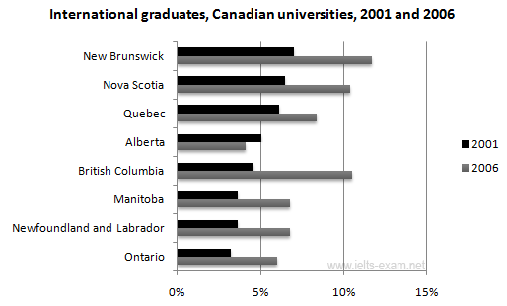
b. Identify errors and rewrite the following sentences. 4x1=4M
- Both of them did not pass the test.
- Each of these girls sing very well.
- He is waiting for you from 10 o’clock.
- I am going to school by bus.
OR
    - a. Convert the following information into a meaningful paragraph.
The given graph shows the main sources of energy for USA in 1980 and 1990. 4M
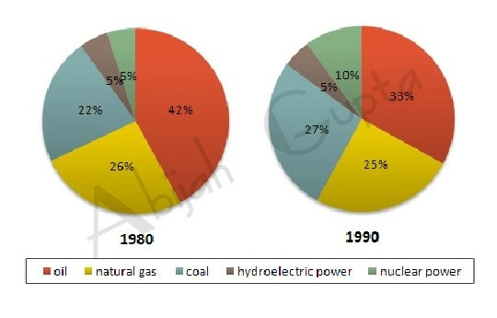
b. Identify errors and rewrite the following sentences 4x1=4M
i. Hardly the sun had risen when we set out
ii. It is high time she improves her behaviour.
iii. The sceneries here are beautiful.
iv. This is my house, I live here.

